**SmartGolf Token (SGi)**

**Whitepaper v4.0.4**

**Abstract**

SmartGolf Token (SGi) bridges real-world golf training and tokenized digital rewards. With 4,000+ devices sold and PGA endorsement, SGi is a proven use case of AI and blockchain in sports. SGi stands out from typical Web3 projects by anchoring its foundation in proven innovations: over 4,000 IoT golf clubs sold globally, patented technologies recognized in the U.S. and Korea, and endorsements from PGA professionals. These achievements bridge real-world successes with Web3's potential, combining biometric motion data, AI coaching, and a robust tokenized economy to transform how golfers engage with their sport and digital assets.

1. **Problem Statement**

**Current Issues:**

* Golf is perceived as an elite sport with limited accessibility, lacking systems that incentivize participation.
* Existing platforms like screen golf or driving ranges are restricted to certain users, without mechanisms to reward engagement.

만화 영화, 스크린샷, 애니메이션이(가) 표시된 사진

AI가 생성한 콘텐츠는 부정확할 수 있습니다.

**Proposed Solution:**

* SmartGolf integrates IoT-based golf clubs and AI coaching systems to analyze swing data in real-time, recording it on the blockchain to reward participation.
* SmartGolf Plaza extends the Web3 experience offline, enhancing user engagement through physical locations.

1. **Technical Overview**

**Core Technologies:**

* **IoT Golf Clubs:** Equipped with 9-axis motion sensors to collect real-time swing data, visualized in 3D.
* **AI Coaching Engine:** Provides personalized coaching based on over 4,000 categorized swing data points.
* **Blockchain Integration:** Utilizes ERC-20 SGi tokens to link offline activities to digital assets.

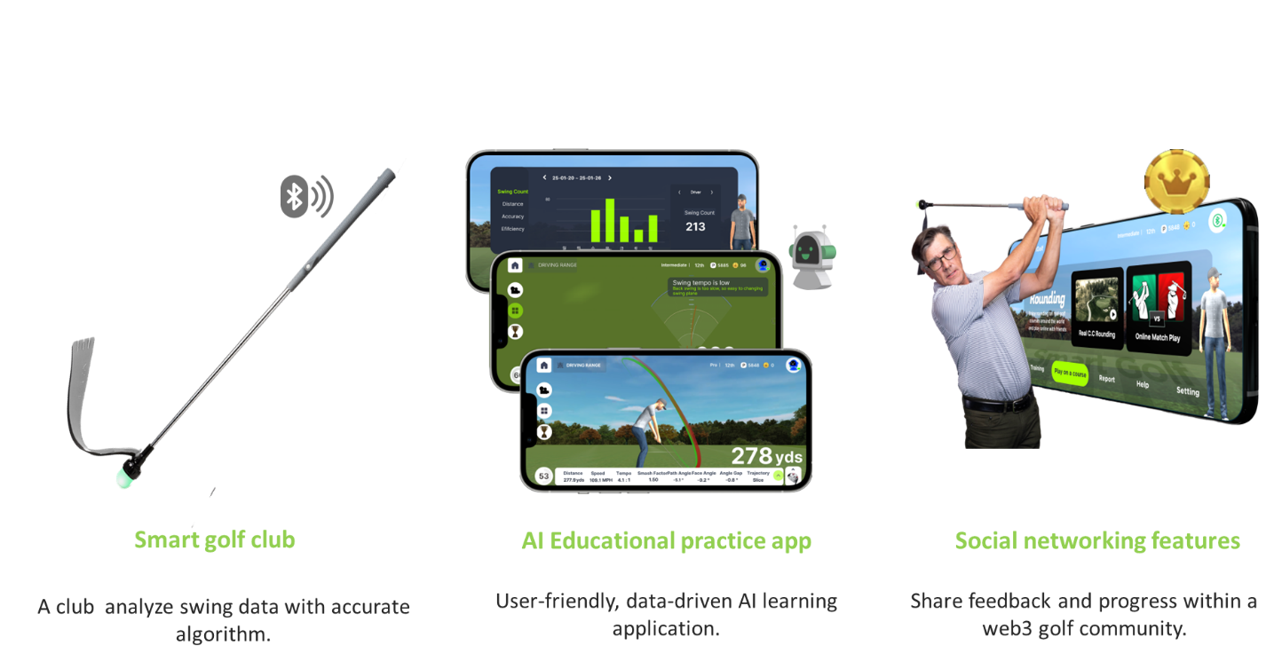

**Security and Standards:**

* **Swing NFTs:** Each swing is issued as a unique NFT, ensuring data integrity.
* **Smart Contracts:** Implemented for reward systems, DAO governance, and exchange integrations.
* **KYC & Privacy Protection:** Employs zk-hash-based on-chain KYC to safeguard user information.

| **Layer** | **Function** | **Example** |
| --- | --- | --- |
| **Swing NFT Contract** | Issues NFTs per validated swing; links metadata from motion sensors | mintSwingNFT() |
| **Reward Contract** | Calculates SGI Points and converts to SGI Coins based on on-chain activity | claimRewards() |
| **Marketplace Contract** | Enables users to trade swing NFTs or book AI coaching sessions | listSwingForSale() |
| **DAO Governance Contract** | Handles proposals, voting, and treasury logic | voteOnProposal() |

All contracts follow upgradeable architecture (EIP-1967 proxy pattern), with regular audits and version tracking.

**On-chain KYC by Swing**

Each user’s swing signature is stored as a unique multi-sensor pattern (15 IMU inputs), enabling biometric-style verification.

* **Biometric Motion Signature**: Each swing generates a unique 15-sensor pattern (IMU), hashed and stored on-chain.
* **User KYC Hash Mapping:** Users’ identities are mapped to swing hashes via on-chain KYC integration, ensuring privacy-compliant authentication.

**Reward Flow Model**

flowchart LR

A[Practice Swing] --> B[Upload via App]

B --> C{Validated?} -->|Yes| D[Mint NFT]

D --> E[Earn SGI Points] --> F[Convert to SGI Coin] --> G[Use in Ecosystem]

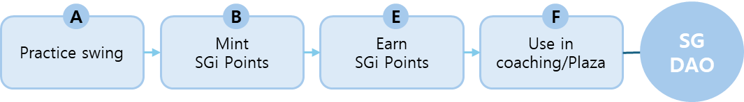

**Competitive Advantage**

* **Patented Technology**: Protected by U.S. and Korean patents, the IoT golf club technology is a proven game changer.
* **Commercial Success**: Over 4,000 units sold through crowdfunding campaigns, demonstrating market traction.4K units sold via crowdfunding
* **Real-World Impact:** Strong partnerships with education systems and PGA professionals solidify SGI's relevance and scalability

**Why It Matters**

* Real-time motion data → on-chain value via NFT + ERC20
* Fixed supply + burn model = deflationary incentive loop
* Full transparency: DAO-voted governance + open metrics

1. **Tokenomics**

**Token Structure:**

* **Total Supply:** 400 million SGi tokens.
* **Swing Generation:** 1 swing converts 1~3 SmartGolf points
* **Conversion:** 1,000 SmartGolf Points = 1 SGi Token
* **Utility:** Used for equipment purchases, coaching sessions, event participation, and DAO governance.

**Distribution Plan:**

* **Public Sale:** 30%
* **Private Round:** 15%
* **PGA/Associations:** 10%
* **Business Reserve:** 15%
* **Team:** 10%
* **Advisors:** 10%
* 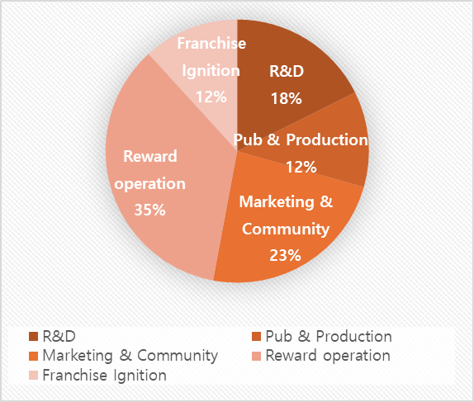**Early Investors:** 10%

**Fund Allocation:**

* **Rewards & Operations:** 35%
* **Marketing & Community:** 23%
* **R&D:** 18%
* **Manufacturing:** 12%
* **Franchise Launch: 12%**

**Private Sale Terms & Vesting**

Early contributors benefit from tiered SGi token pricing and structured vesting schedules to promote long-term alignment. The public sale price is set at $1.00 per SGi token, in alignment with its internal utility valuation.

**Private Sale Opportunity:**

|  |  |  |  |
| --- | --- | --- | --- |
| **Round** | **Price per SGi (USD)** | **Discount vs $1.00 peg** | **Vesting Schedule** |
| Seed | $0.40 | 50% off | 3-month cliff, 12-month linear vesting |
| Strategic | $0.65 | 35% off | 1-month cliff, 9-month linear vesting |
| Private | $0.75 | 25% off | 1-month cliff, 6-month linear vesting |
| Public Sale | $0.85 | 15% off | Fully unlocked |

This structure ensures price fairness while rewarding early believers. Vesting is enforced via smart contracts.

**Dual Valuation Context:** SGi's public sale price is set at $1.00, reflecting its internal utility value when applied toward real-world products such as the AIX Club. For example:

* 500 SGi + 1 AIX Club = $500 → SGi = $1.00
* 1,000 SGi + 1 AIX Club = $1,000 → SGi = $1.00

The public sale price of SGi is set at **$0.85 per token**, offering a 15% entry incentive compared to the internal utility value of $1.00.  
This ensures ecosystem consistency while rewarding new community members with early access benefits.

**Utility Components:**

* Access to AI swing coaching modules
* Minting and trading swing-based NFTs
* Entry into SmartGolf Plaza events and competitions
* Participation in DAO governance and platform voting
* Physical rewards (e.g., AIX Club) via token holding tiers

**Reward Integration Model:**

|  |  |  |  |
| --- | --- | --- | --- |
| **Round** | **SGi Holding Threshold** | **Reward** | **Description** |
| **Bronze** | 500 SGi | 1 AIX Club | Entry-level real swing experience with token utility |
| **Silver** | 1,000 SGi | 1 AIX Club + Swing NFT rights | Active user tier with digital asset engagement |
| **Gold** | 3,000 SGi | All above + DAO voting priority + Plaza event pass | Ecosystem contributor + governance enabler |

SGi holders can unlock a combination of physical rewards, digital features, and community governance rights. This tiered model supports both mass adoption and incentivized participation, while reinforcing SGi’s identity as a non-securitized, real-world utility token.

**Ecosystem Components**

**SGi Pool**

**Online Match**

/ 1:1 match

**Promotion**

/ Collaboration with **LV**



**Public**

/ School Lesson



**Ecosystem**

Food

Beverage



Analysis



Lesson



Course



Products



Swing Token



**Pro Coaching**

/ Lesson Participation



**Golf Tour**

/Wining Prize

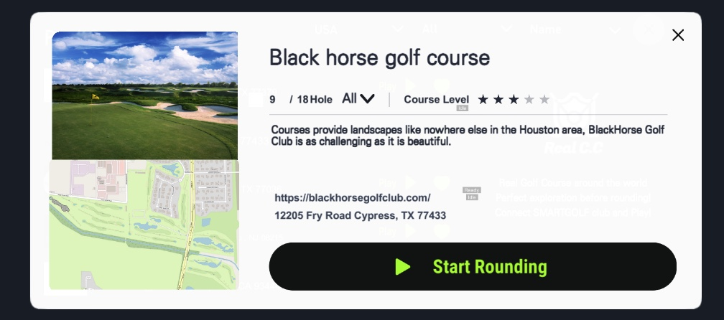

**Golf Rounding**

/Global 500 golf courses

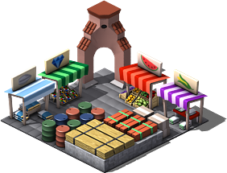

**SMARTGOLF Pub**

/ Local Community

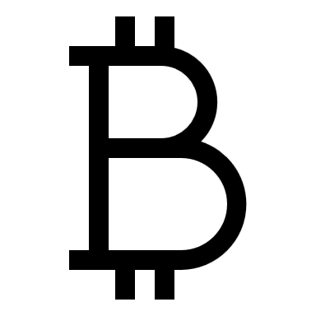

**Coin Exchange**

/ERC20



**Gallery Support**

/Participation, betting

**Swing Practice**

/ Data provide & get Points

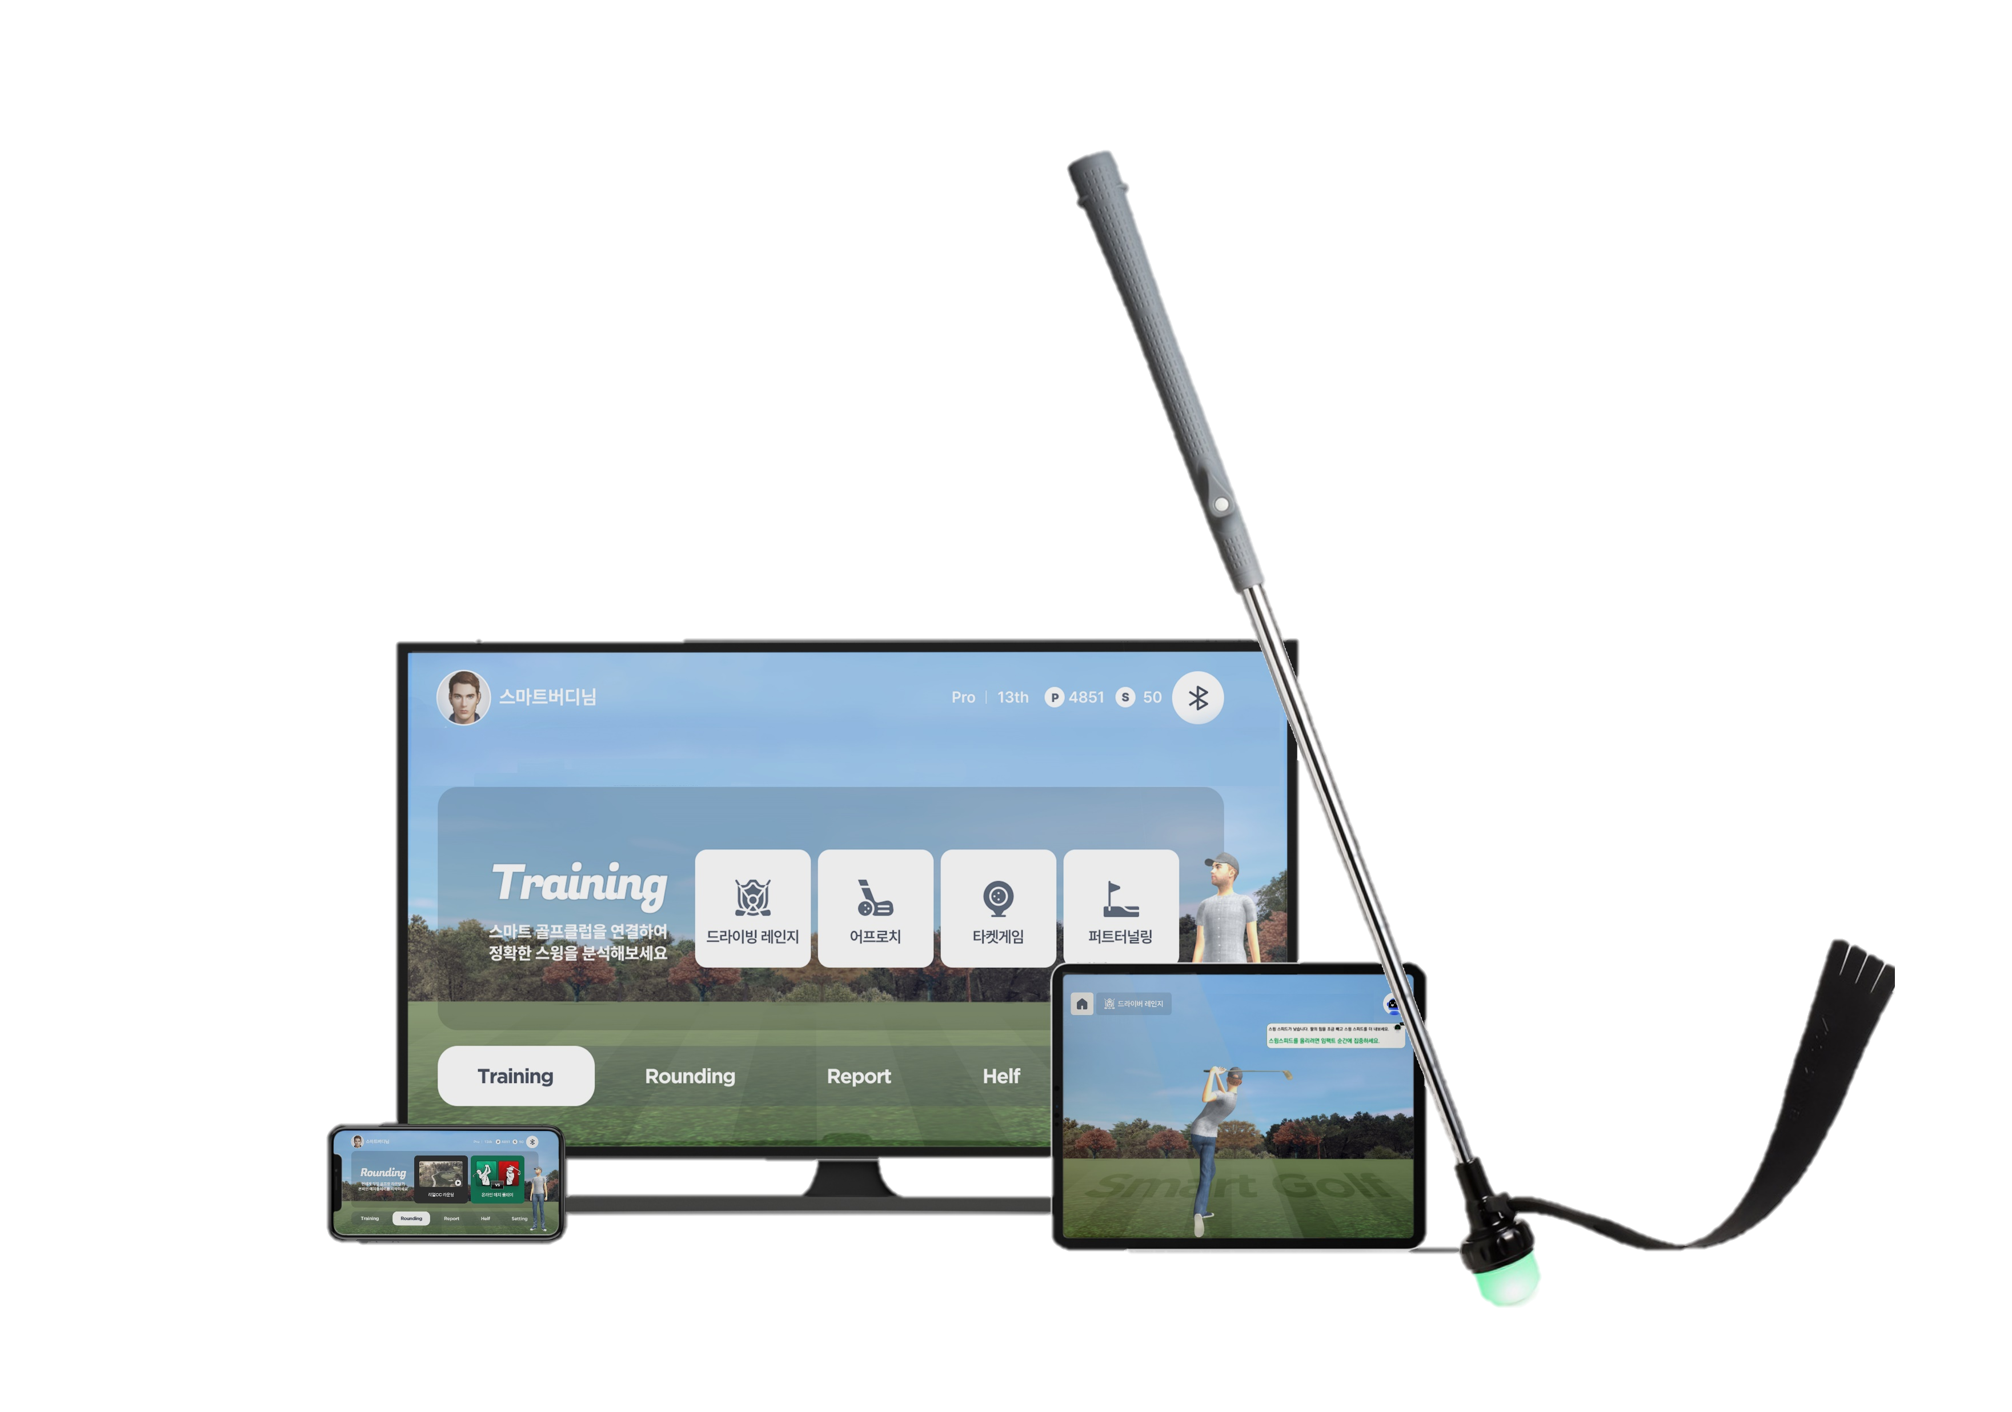

**SMARTGOLF Engagement**

/ Swing Record, AI coaching

* **SmartGolf Club**: Sensor-driven IoT golf hardware
* **SmartGolf App**: Swing analysis, AI feedback, digital wallet
* **SmartGolf Plaza**: Real-world venue for token-based gaming
* **Blockchain Layer**: NFT issuance, DAO governance, token economy

1. **Use Cases**

**Use Case I – Swing Tokenization**

* **Players** swing with a SmartGolf club at home, and the motion is recorded and tokenized on-chain. These Swing NFTs can be used for rewards, coaching, or trading.

**Use Case II – SmartGolf Plaza Economy**

* **Users** engage in competitions or betting at SmartGolf Plaza, receiving SGi tokens as rewards, with all activities recorded on the blockchain..

1. SmartGolf Plaza (Could be done at home with SmartGolf app + club)
2. Player and Galley log in to the SmartGolf System.
3. Engage (rounding on course or betting as gallery) in the virtual multi-round on SG course.
4. Wins the round and received prize (tokens) as a reward.

**Use Case III – Additional Coaching**

* **Users** connect with certified coaches through the platform for coaching sessions, with fees and feedback processed via smart contracts in SGi tokens.

1. SmartGolf system – The user swings and the swing data is transferred to a matched coach.
2. The swing data will be analyzed, visualized on the SmartGolf App for a detailed review from the coach followed by specific instructions on methods to improve the user’s swing.
3. The overall tuition fee is paid through a transaction via the SmartGolf digital wallet
4. **Market Opportunity**

* **Global Golf Population:** 65 million.
* **U.S. Golf Equipment Market Size:** $15.8 billion.
* **Digitized Golf Courses:** Over 500.
* **Active Partnerships:** 5 schools in Houston, collaborations with PGA professionals.

1. **Team**

**Core Team:**

* **Jongmin Kim (CEO):** Founder of SmartGolf, leading the vision to integrate golf and blockchain technologies.
* **Moon Jang(Software Development):** Responsible for the development of SmartGolf platform software and integration of AI and IoT technologies.
* **Sion Lee(Server Development):** Manages scalable and secure server systems and integrates blockchain technologies.
* **Jason Oh(Tokenomics):** MBA & Doctor of Blockcahin Economics

**Professional Golf Ambassadors:**

* **Steve Parker**, **Steve Jurgenson**, **Matthew Williams**, **JJ Wood, JH Park:** PGA coaches and tour players endorsed SmartGolf accuracy, helping to increase SmartGolf's brand recognition and credibility.

**Global Partners:**

* **Terry Williams(USA), Fraser Warren (Netherlands), Norimasa Morita(Japan) :** Assisting in regional market expansion and user adoption strategies.

1. **Roadmap Highlights**

* **2015–2023**: R&D, crowdfunding, hardware launch, PGA endorsement
* **2024**: School partnerships, major exhibitions partner (VivaTech, ExpandNorthStar)
* **2025 Q2:** Token smart contract deployed (SGi live on-chain)
* **2025 Q3**: Launch staking & utility token features (CEX listing under partner review)
* **2025 Q4**: Activate NFT swing minting & DAO voting rights

1. **Governance & DAO Structure**

* **SGi Holders:** Participate in votes on platform upgrades, tokenomics adjustments, and coach onboarding protocols.
* **Financial Management:** Multi-signature DAO board oversees finances, providing quarterly transparency reports.
* **Community Proposals:** Open governance portal for community suggestions, utilizing Snapshot-style voting.

텍스트, 스크린샷, 폰트, 디스플레이이(가) 표시된 사진

AI가 생성한 콘텐츠는 부정확할 수 있습니다.

**9. Risk Factors**

**Standard Web3 Risks:**

* **Blockchain Volatility:** As with any Web3 project, fluctuations in the blockchain market can impact token values.
* **Regulatory Uncertainty:** While the regulatory landscape for cryptocurrencies is still evolving, SmartGolf Token (SGi) has been designed as a **Utility Token** rather than a Security Token. This distinction ensures that SGi complies with regulatory frameworks governing utility tokens, which are typically more favorably accepted by regulatory authorities. The token's creation and use are fully integrated within the **SmartGolf ecosystem**, which mitigates regulatory risk by ensuring that SGi's primary function is as a utility for real-world golf training, AI coaching, and community participation. We believe this approach reduces exposure to the potential risks associated with Security Token regulations.
* **Security Vulnerabilities:** Risks related to wallet security and potential exploits of smart contracts remain prevalent. However, SmartGolf's smart contracts are built with upgradeable architecture and undergo regular audits to minimize vulnerabilities.
* **Market Adoption Dependency:** The success of SmartGolf is largely dependent on its adoption by golfers, coaching professionals, and the global golf community. Scaling the platform and ensuring widespread user participation is key to the ecosystem’s success.

**10. Conclusion**

SmartGolf Token (SGi) combines golf and blockchain innovation to open new horizons in the sports industry. With tangible applications like IoT golf clubs, PGA endorsements, and strong partnerships with educational systems, SGi is building a trustworthy and scalable ecosystem. By converting swing data into valuable on-chain assets and providing a decentralized yet proven infrastructure, SGi turns physical golf swings into blockchain utility. **SmartGolf is not an idea. It’s a real product with real users – and now, a real token.**  
The future of golf is data-driven, decentralized, and rewarding.

**More info:**  
🌐 Website: smartgolf.io  
🔗 GitHub: github.com/SmartGolfDAO  
💬 Telegram: t.me/SmartGolfSGi  
🐦 Twitter: @SmartGolfDAO